**WEB APPLICATION DEVELOPMENT**

**DEPARTMENT OF COMPUTER SCIENCE AND ENGINEERING**

**SRKR ENGINEERING COLLEGE(A)**

**BHIMAVARAM**



**Project Name: Rockstar Hotels.**

**Project by Y.J.S.S.D.Balaji**

**20B91A05W1-CSE-D**

**. Project title: Rockstar Hotel .**

**ABSTRACT**

Rockstar Hotels , A project that is built to scout particulars about the hotel which makes a delightful experience to the user. This web application mainly focus on thoughts of the user which they are impatient to know about. All the facilities and infrastructural information is provided in the website

**DESCRIPTION**

Rockstar hotels provides you the essential information with different categories and with different sections. This webpage provides the features for exploring facilities of rooms, all sections of the hotel, menu of restaurant, support team. The function halls which were built in this are very special arranged in different format compared to others

**REQUIREMENTS:**

1.Web Browser

2.Visual Studio Code

**RESOURCES USED:**

1.HTML

2.CSS

3.Google Images

4.Visual studio Code

**WEB APPLICATION STRUCTURE:**

**Rockstar Hotels.**

1.MainPage:frames

I)top.html

II)menu.html

III)home.html

1.Home: home.html

BookNow thanks.html

2.Rooms: rooms.html

BookNow thanks.html

3.Gallery: gallery.html

4.Restaurent : restaurant.html

Menu menu(1).html

ADD add.html

5.Contactus : contactus.html

BookNow thanks.html

**HOMEPAGE**

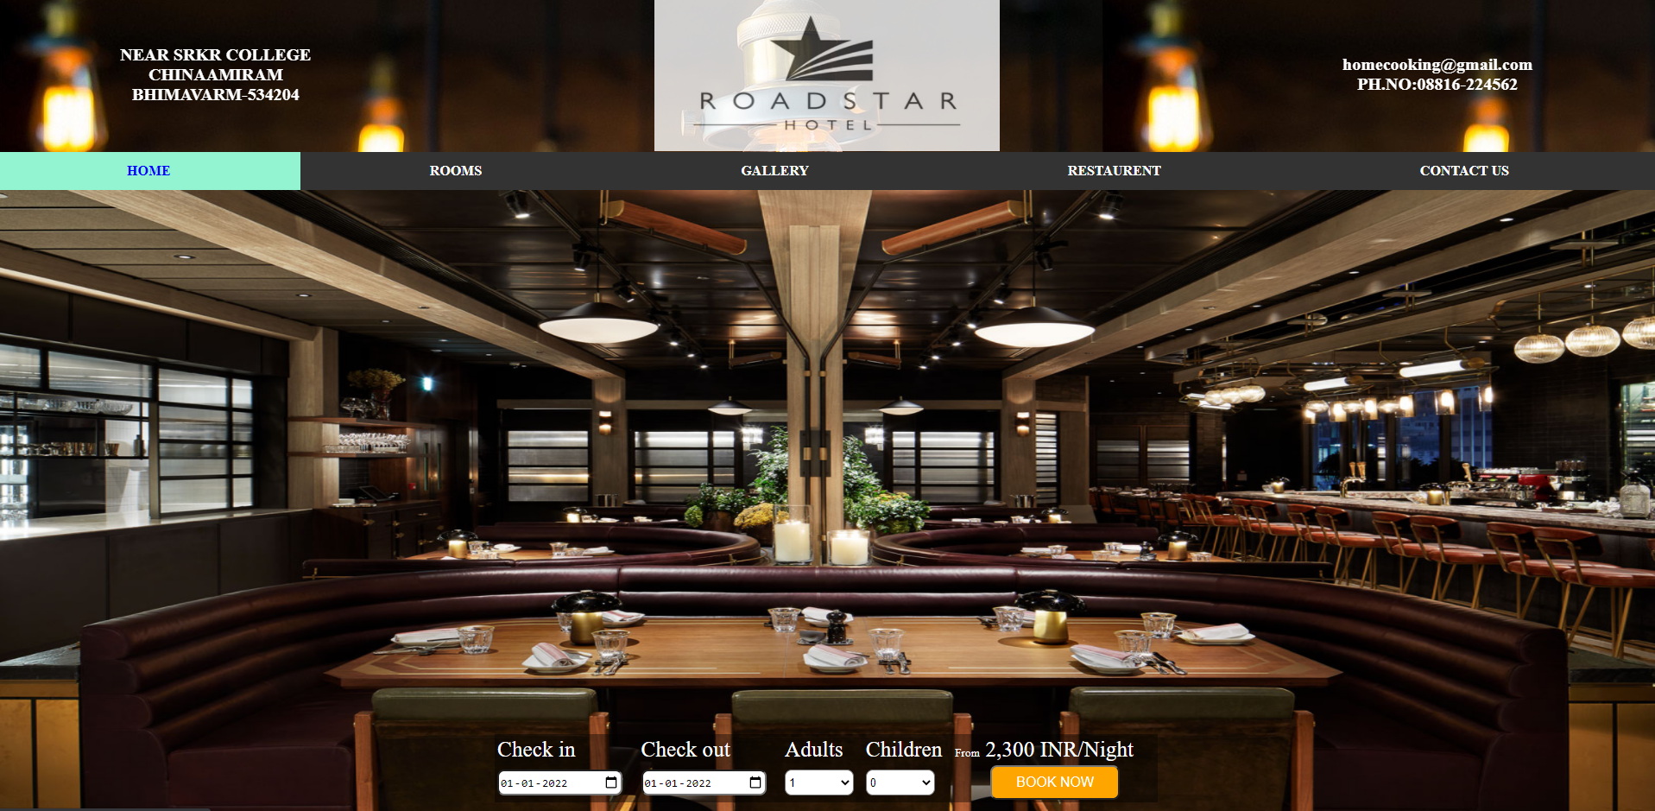

**Main.html**

<!DOCTYPE html>

<html>

 <head>

<title>HTML Target Frames</title>

 </head>

<frameset rows = "18.8%,4.6%,*" frameborder="0">

    <frame name = "top" src="top.html" marginwidth="0" marginheight="0"/>

      <frame name = "middle" src="menu.html" marginwidth="0" marginheight="0" />

      <frame name = "M" src="home.html" marginwidth="0" marginheight="0" />

 </frameset>

</html>

**Top.html**

<html>

<head>

<style>

table,tr, td {

  border: 0px solid black;

  border-collapse: collapse;

  text-align:center;

  color: white;

  background-size: auto;

}

</style>

</head>

<body >

  <center>

<table  background="C:/Users/yjaya/Desktop/background.jpg" style="width:100%">

  <tr>

    <td style="font-size:20px" >

<b>NEAR SRKR COLLEGE<br>

    CHINAAMIRAM<br>

    BHIMAVARM-534204

        </b></td>

    <td><img src="C:/Users/yjaya/Desktop/image1(2).png"  width=400px height=178px style="opacity:0.8"></td>

    <td style="font-size: 20;"><b>

           homecooking@gmail.com<br>

           PH.NO:08816-224562

        </b></td>

  </tr>

</table>

</center>

</body>

</html>

**Menu.html**

<html>

<head>

<style>

ul {

  list-style-type: none;

  margin: 0;

  padding: 0;

  overflow: hidden;

  background-color: #333;

}

li {

  float: left;}

li a {

  display: block;

  color: white;

  text-align: center;

  padding: 13px 150px;

  text-decoration: none;

}

li a:hover {

  background-color: #93F4D1;

  color:blue;

}

</style>

</head>

<body>

<ul>

  <li><a href="home.html" target="M"><b>HOME</b></HOME></a></li>

  <li><a href="rooms.html" target="M"><b>ROOMS</b></a></li>

  <li><a href="gallery.html" target="M"><b>GALLERY</b></a></li>

  <li><a href="restaurent.html" target="M"><b>RESTAURENT</b></a></li>

  <li><a href="aboutus.html" target="M"><b>CONTACT US</b></a></li>

</ul>

**home.html**

<html>

<head>

<style>

img{

position: absolute;

top:0px;

left: 0px;

z-index: -1;

}

.rounded

{

    border-radius:8px;

    background-color: orange;

    color: white;

}

.round

{

    border-radius:8px;

    background-color: white;

    color: rgb(5, 3, 3);

}

table,tr,td{

    color:white;

    font-family:'Times New Roman';

    font-size: 19pt;

    padding: 3x;

    border: 1px black;

    }

</style>

</head>

<body bgcolor="#EFF74A">

<form action="thanks.html">

<br><br><br><br><br><br><br><br><br><br><br><br>

<br><br><br><br><br><br><br><br><br><br><br><br>

<br><br><br><br><br><br><br><br><br><br><br>

<center>

<table style="background: rgba(0,0,0,.4)" width=40%>

<tr>

    <td>Check in</td>

    <td>Check out</td>

    <td>Adults</td>

    <td>Children</td>

    <td><label style="font-size:10pt">From</label> 2,300 INR/Night</td>

</tr>

<tr>

    <td><input class="round" value="2022-01-01" type="date" style="height:30px"></td>

    <td><input class="round" value="2022-01-01" type="date" style="height:30px"></td>

    <td><select class="round" style="height:30px; width:80px">

        <option value=1>1</option>

        <option value=2>2</option>

        <option value=3>3</option>

        <option value=4>4</option>

    </select></td>

    <td><select class="round" style="height:30px; width:80px">

        <option value=0>0</option>

        <option value=1>1</option>

        <option value=2>2</option>

    </select></td>

    <td align="center"><input style="font-size:12pt;height:40px; width:150px" class="rounded" value="BOOK NOW" type="submit" ></td>

</tr>

</center>

</table>

</form>

<div>

    <img src="hotel.jpg" width=100% height=737px >

</div>

</body>

</html>

**BOOKNOW PAGE**



**Thanks.html**

<html>

    <head>

        <style>

        body{

            background-image: url("thanks.jpg");

            background-repeat: no-repeat;

            background-size: cover;

        }

        p{

            font-family: Cambria, Cochin, Georgia, Times, 'Times New Roman', serif;

            font-size: 40pt;

            font-weight: bolder;

            color:white;

            margin-left: 550px;

            margin-top: 400px;

        }

        </style>

    </head>

<body>

    <p>Thanks for choosing our hotel<br>Enjoy your stay.</p>

 </body>

</html>

___________________________________________________________________________________________

**ROOMS PAGE**

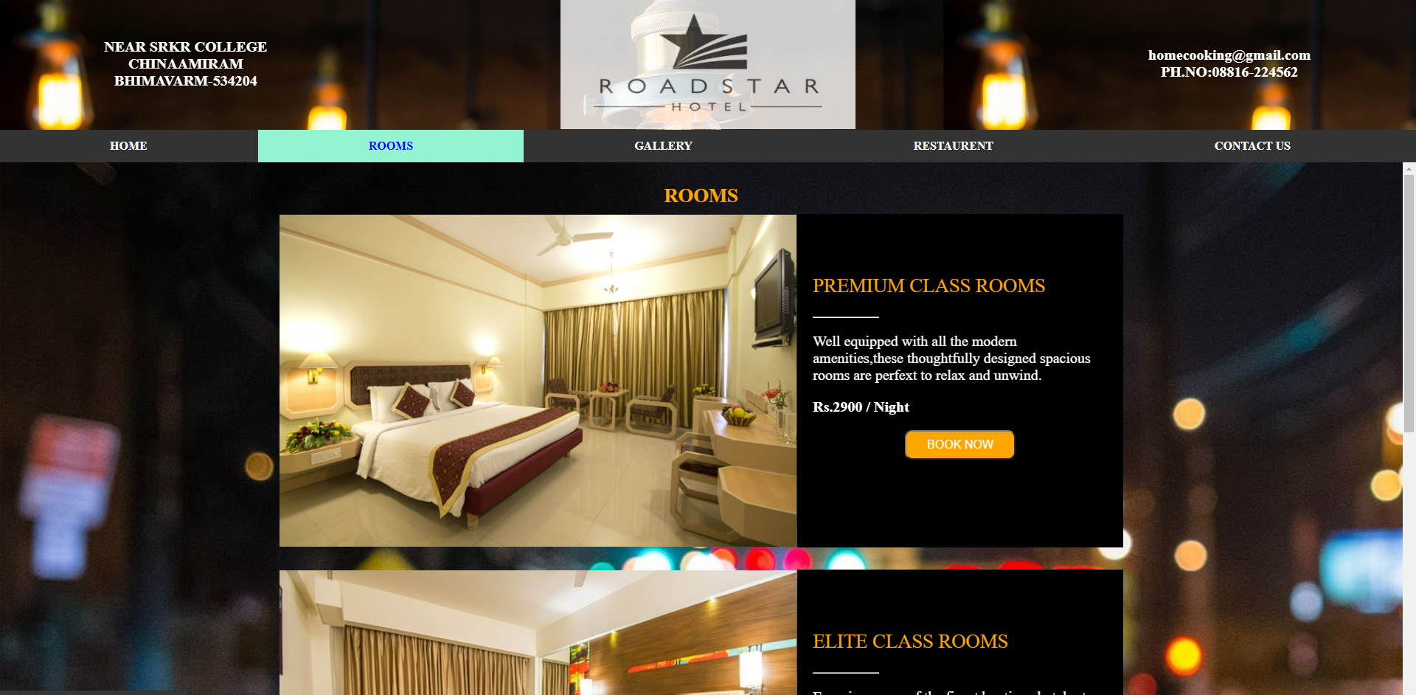

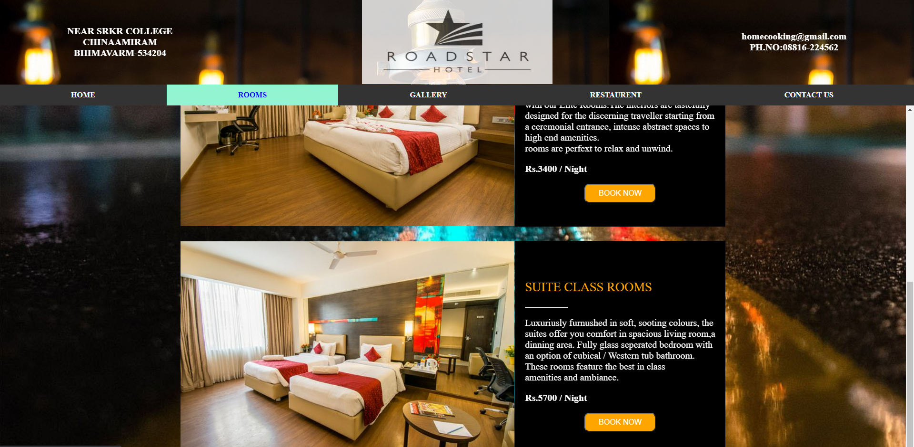

**Rooms.html**

<html>

  <head>

      <style>

          table,tr,td{

              border:0px solid black;

              border-collapse:collapse;

              color:white;

          }

          p{

              margin-left:20px;

              margin-right:20px;

          }

          .r{

            font-size:12pt;

            height:40px;

             width:150px;

             border-radius:10px;

             background-color: orange;

             color:white;

          }

          body{

              background-image:url("roomsbk.jpg");

              background-repeat: no-repeat;

              background-size:cover;

          }

      </style>

  </head>

  <body>

    <form action="thanks.html">

        <center>

      <table style="margin-top: 20px;">

          <tr>

              <td colspan="2" style="text-align:center;height:50px;"><p class="p" style="font-size:20pt;color:orange;"><b>ROOMS</b></p></td>

          </tr>

          <tr>

              <td>

                  <img  src="room1.jpg" style="width:701;height:450px" >

             </td>

              <td style="vertical-align:top;background-color:black;">

                <br><br><br>

                <p class="p" style="font-size:20pt;color:orange">PREMIUM CLASS ROOMS</p>

                <hr class="p" style="width:20%;margin-left:20px;">

                <p class="p" style="font-size:15pt">Well equipped with all the modern <br>

                    amenities,these thoughtfully designed spacious<br>

                    rooms are perfext to relax and unwind.</p>

                <p class="p" style="font-size:15pt"><b>Rs.2900 / Night</b></p>

                <center>

                <p><input class="r" value="BOOK NOW" type="submit"> </p>

                </center>

            </td>

          </tr>

          <tr>

              <td style="height:30px"></td>

          </tr>

          <tr>

            <td>

                <img  src="room2.jpg" style="width:701;height:450px" >

           </td>

            <td style="vertical-align:top; background-color:black;">

              <br><br><br>

              <p class="p" style="font-size:20pt; color:orange">ELITE CLASS ROOMS</p>

              <hr class="p" style="width:20%; margin-left:20px;">

              <p class="p" style="font-size:15pt">Experience one of the finest boutique hotels stay<br>

                  with our Elite Rooms. The interiors are tastefully <br>

                  designed for the discerning traveller starting from<br>

                   a ceremonial entrance, intense abstract spaces to<br>

                   high end amenities.<br>

                  rooms are perfext to relax and unwind.</p>

              <p class="p" style="font-size:15pt"><b>Rs.3400 / Night</b></p>

              <center>

              <p><input class="r" value="BOOK NOW" type="submit"></p>

              </center>

          </td>

          </tr>

          <tr>

            <td style="height:30px"></td>

        </tr>

        <tr>

          <td>

              <img  src="room3.jpg" style="width:701;height:450px" >

         </td>

          <td style="vertical-align:top;background-color:black;">

            <br><br><br>

            <p class="p" style="font-size:20pt;color:orange">SUITE CLASS ROOMS</p>

            <hr class="p" style="width:20%;margin-left:20px;">

            <p class="p" style="font-size:15pt">Luxuriusly furnushed in soft, sooting colours, the <br>

                suites offer you comfort in spacious living room,a <br>

                dinning area. Fully glass seperated bedroom with<br>

                an option of cubical / Western tub bathroom.<br>

                These rooms feature the best in class<br>

                amenities and ambiance.<br>

                </p>

            <p class="p" style="font-size:15pt"><b>Rs.5700 / Night</b></p>

            <center>

            <p><input class="r" value="BOOK NOW" type="submit"> </p>

            </center>

        </td>

        </tr>

          </table>

        </center>

        </form>

    </body>

</html>

**GALLERY PAGE**

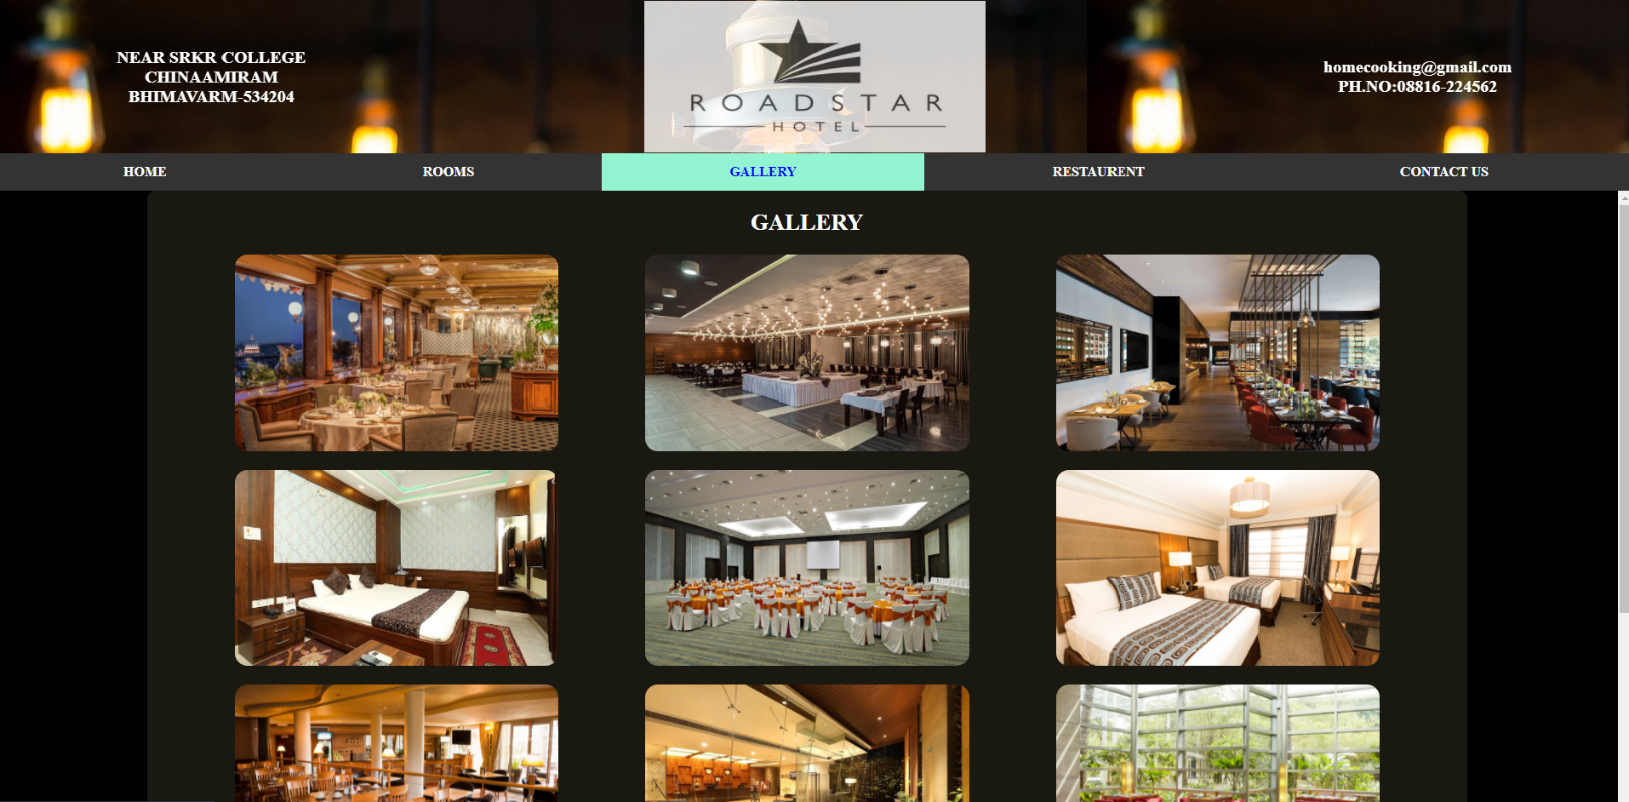

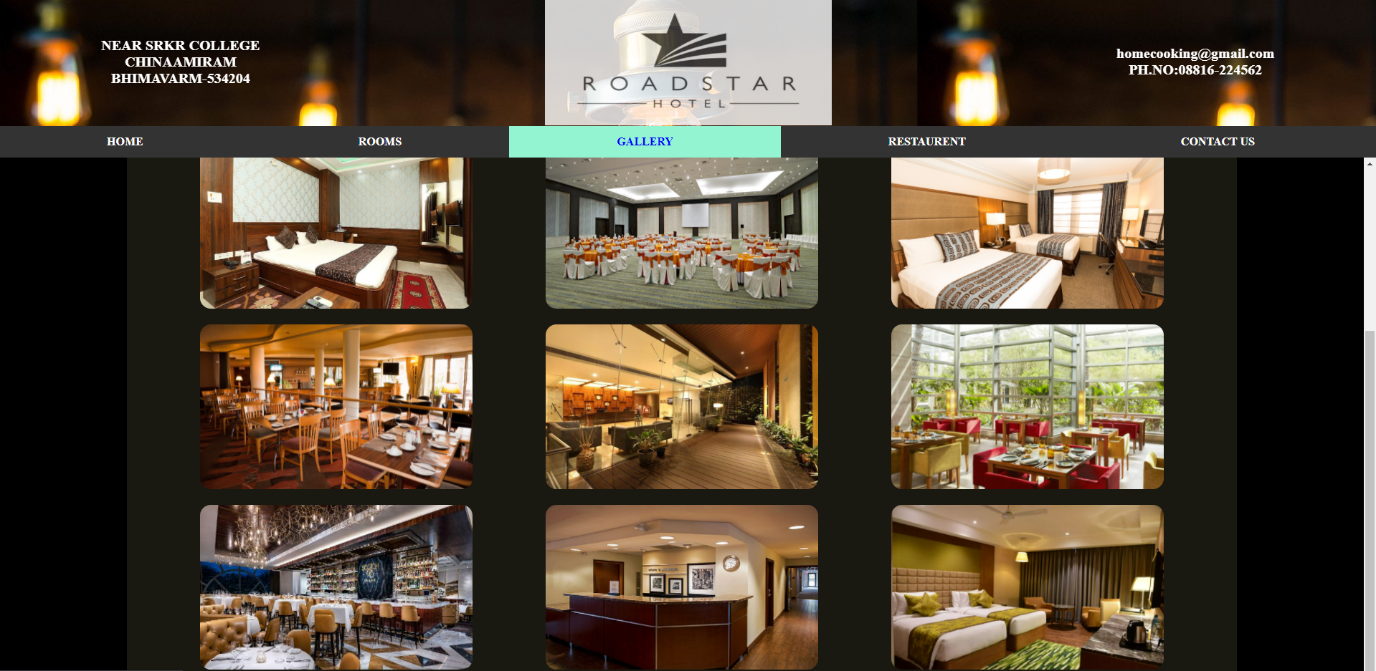

**Gallery.html**

<html>

<head>

<style>

table,td,tr {

border: 0px solid black;

padding:10px 50px;

border-radius: 10px;

font-size:20pt;

}

img{

border-radius: 15px;

}

td img:hover{

transform:scale(1.1);

}

</style>

</head>

<body bgcolor="black">

<center>

<table style="background: rgba(243, 242, 181,0.1)">

<tr>

<td colspan="3" align="center" style="color:white"><b>GALLERY</b></td>

</tr>

<tr>

<td><img src="g3.jpg" style="width:380px ;height:230px" ></td>

<td><img src="g4.jpg" style="width:380px ;height:230px" ></td>

<td><img src="g5.jfif" style="width:380px ;height:230px" ></td>

</tr>

<tr>

<td><img src="g6.jpg" style="width:380px ;height:230px" ></td>

<td><img src="g7.jpg" style="width:380px ;height:230px" ></td>

<td><img src="g8.png" style="width:380px ;height:230px" ></td>

</tr>

<tr>

<td><img src="g9.jpg" style="width:380px ;height:230px" ></td>

<td><img src="g10.jpg" style="width:380px ;height:230px" ></td>

<td><img src="g11.jpg" style="width:380px ;height:230px" ></td>

</tr>

<tr>

<td><img src="g12.jpg" style="width:380px ;height:230px" ></td>

<td><img src="g13.jpg" style="width:380px ;height:230px" ></td>

<td><img src="g14.webp" style="width:380px ;height:230px" ></td>

</tr>

</table>

</center>

</body>

</html>

___________________________________________________________________________________________

**RESTAURENT PAGE**

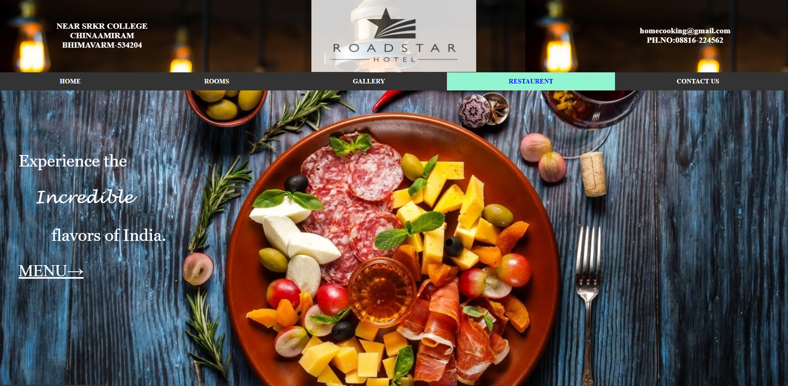

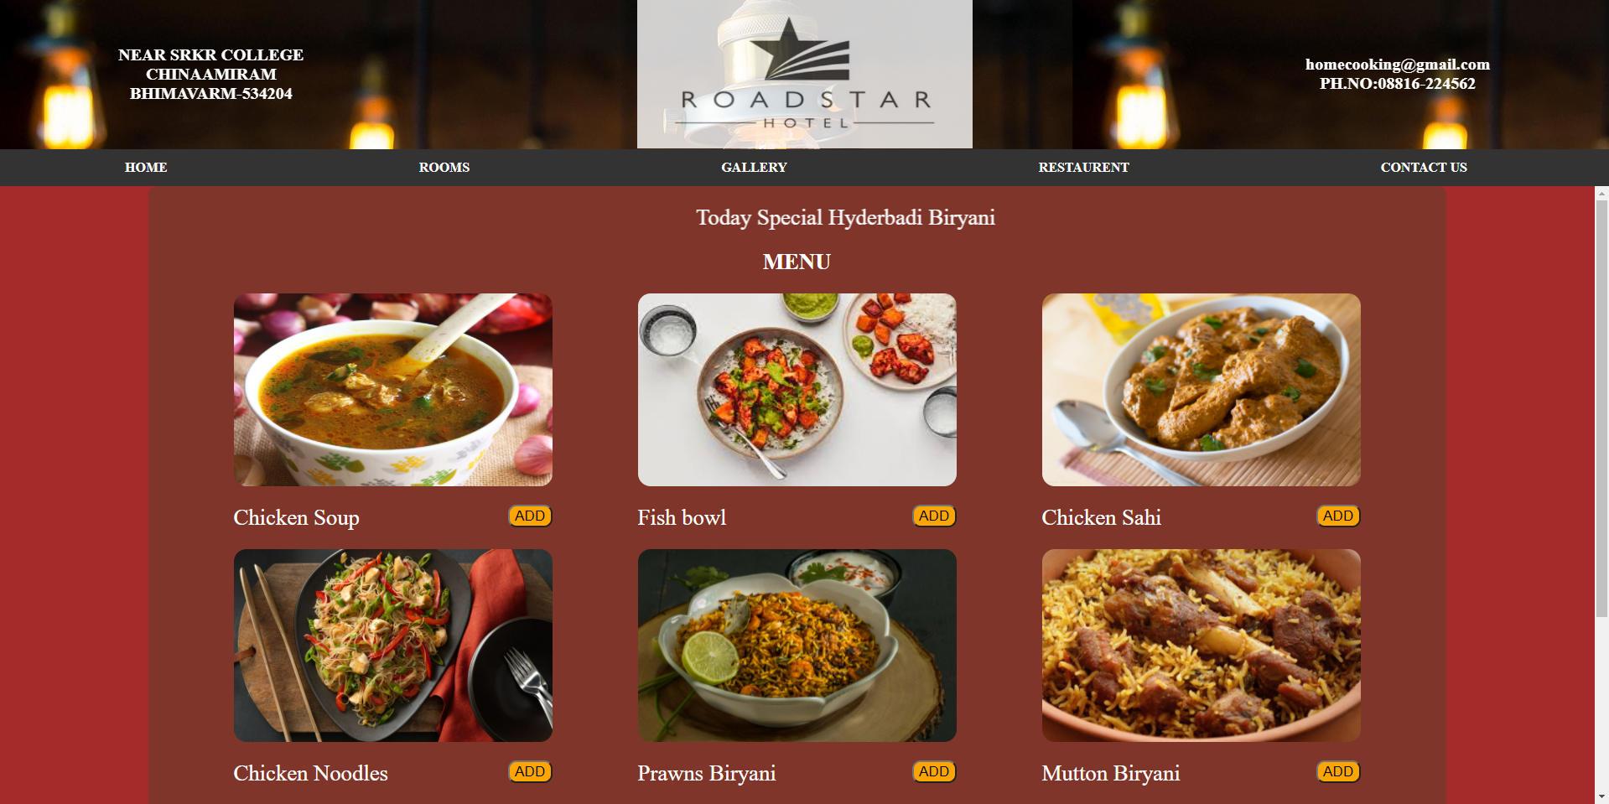

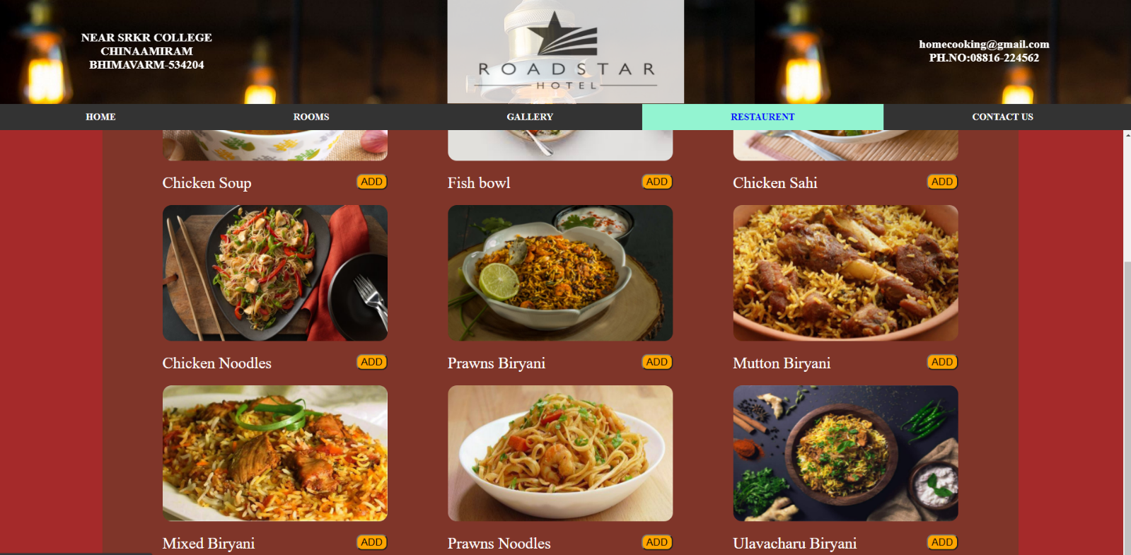

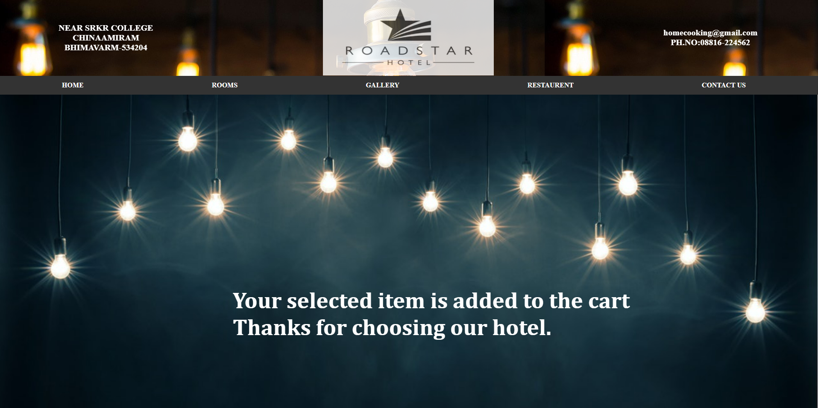

**Restaurant.html**

<html>

<head>

<style>

body{

  background-image:url("restaurent(1).jpg");

  background-repeat:no-repeat;

  background-size: cover;

  margin-left:20px;

}

p{

    color:white;

    font-size: 30pt;

    margin-left:30px;

}

a:hover{

    font-size:40pt;

}

</style>

</head>

<body>

    <br><br><br><br><br><br>

    <p style="margin-left:30px;font-family: Georgia, serif ;">

        Experience the

    </p>

    <p style="margin-left:70px;font-family: lucida handwriting">

        Incredible

    </p>

    <p style="margin-left:110px;font-family:georgia;">

        flavors of India.

    </p>

    <p><a style="color:white;" href="menu(1).html">MENU&rarr;</a></p>

</body>

</html>

**Menu(1).html**

<html>

    <head>

    <style>

    table,td,tr {

        border: 0px solid black;

        padding:10px 50px;

        border-radius: 10px;

        font-size:20pt;

        color: white;

    }

    img{

        border-radius: 15px;

    }

     td img:hover{

         transform:scale(1.1);

    }

    input{

        float:right;

        font-size: 13pt;

        border-radius:10px;

        background-color: orange;

        color: black;

    }

    </style>

    </head>

    <body  bgcolor="brown">

        <form action="add.html">

         <center>

        <table style="background: rgba(71, 71, 41, 0.4)">

        <tr>

             <td colspan="3" align="center" style="color:white"> <marquee width="60%" direction="left" >Today Special Hyderbadi Biryani</marquee>

             </td>

        </tr>

        <tr>

            <td colspan="3" align="center" style="color:white"><b>MENU</b></td>

        </tr>

        <tr>

        <td><img src="r1.png" style="width:380px ;height:230px" ></td>

        <td><img src="r2.jpg" style="width:380px ;height:230px" ></td>

        <td><img src="r3.jpg" style="width:380px ;height:230px" ></td>

        </tr>

        <tr>

            <td>Chicken Soup <input value="ADD" type="submit"</td>

            <td>Fish bowl<input value="ADD" type="submit"</td>

            <td>Chicken Sahi<input value="ADD" type="submit"</td>

        </tr>

        <tr>

            <td><img src="r4.jpg" style="width:380px ;height:230px" ></td>

            <td><img src="r5.jpg" style="width:380px ;height:230px" ></td>

            <td><img src="r6.jpg" style="width:380px ;height:230px" ></td>

        </tr>

        <tr>

            <td>Chicken Noodles<input value="ADD" type="submit"</td>

            <td>Prawns Biryani<input value="ADD" type="submit"</td>

            <td>Mutton Biryani<input value="ADD" type="submit"</td>

        </tr>

        <tr>

            <td><img src="r7.jpg" style="width:380px ;height:230px" ></td>

            <td><img src="r8.jpg" style="width:380px ;height:230px" ></td>

            <td><img src="r9.jpg" style="width:380px ;height:230px" ></td>

        </tr>

        <tr>

            <td>Mixed Biryani<input value="ADD" type="submit"</td>

            <td>Prawns Noodles<input value="ADD" type="submit"</td>

            <td>Ulavacharu Biryani<input value="ADD" type="submit"</td>

        </tr>

    </table>

    </center>

    </body>

</form>

</html>

**Add.html**

<html>

    <head>

        <style>

        body{

            background-image: url("thanks.jpg");

            background-repeat: no-repeat;

            background-size: cover;

        }

        p{

            font-family: Cambria, Cochin, Georgia, Times, 'Times New Roman', serif;

            font-size: 40pt;

            font-weight: bolder;

            color:white;

            margin-left: 550px;

            margin-top: 450px;

        }

        </style>

    </head>

<body>

    <p>Your selected item is added to the cart<br>

    Thanks for choosing our hotel.</p>

</body>

</html>

**CONTACTUS PAGE**

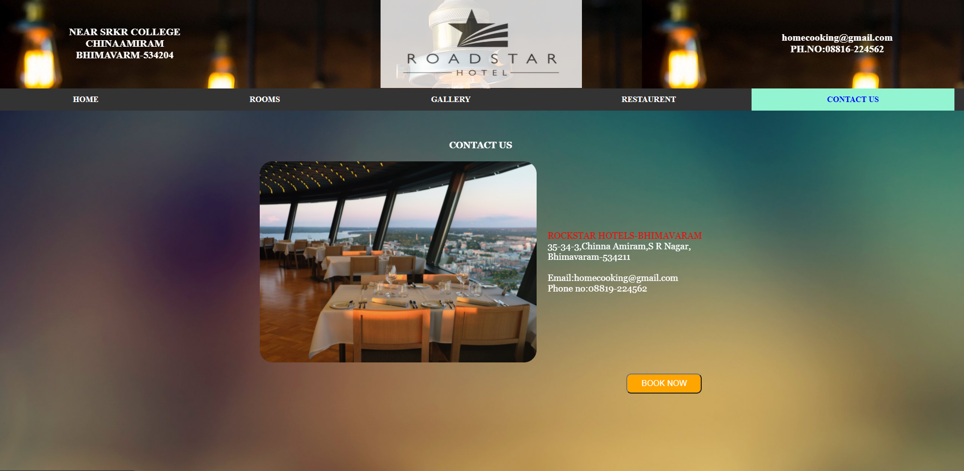

**Contactus.html**

<html>

<head>

    <style>

        table,tr,td{

            padding:10px;

            font-size:18px;

            font-family: Georgia, 'Times New Roman', Times, serif;

            color:white;

        }

        body{

              background-image:url("aboutus.jpg");

              background-repeat: no-repeat;

              background-size:cover;

          }

        img{

            opacity:0.9;

        }

    </style>

</head>

<body>

<form action="thanks.html">

<center>

    <br><br>

    <table >

    <tr>

        <td align="center" colspan="2"><b>CONTACT US</b></td>

    </tr>

    <tr>

        <td>

         <img src="image2.jpg" width=550px height=400px style="border-radius:25px">

        </td>

        <td>

           <label style="color: red;"> ROCKSTAR HOTELS-BHIMAVARAM</label><br>

           35-34-3,Chinna Amiram,S R Nagar,<br>

           Bhimavaram-534211<br><br>

           Email:homecooking@gmail.com<br>

           Phone no:08819-224562

        </td>

    </tr>

    <tr>

    <td align="right" colspan="2"><input style="font-size:12pt;height:40px; width:150px;border-radius:10px;background-color: orange;color:white;"  value="BOOK NOW" type="submit" ></td>

    </tr>

</table>

</center>

</form>

</body>

</html>